**Design Methodology**

**Figure 1**

*Integration Tasks*

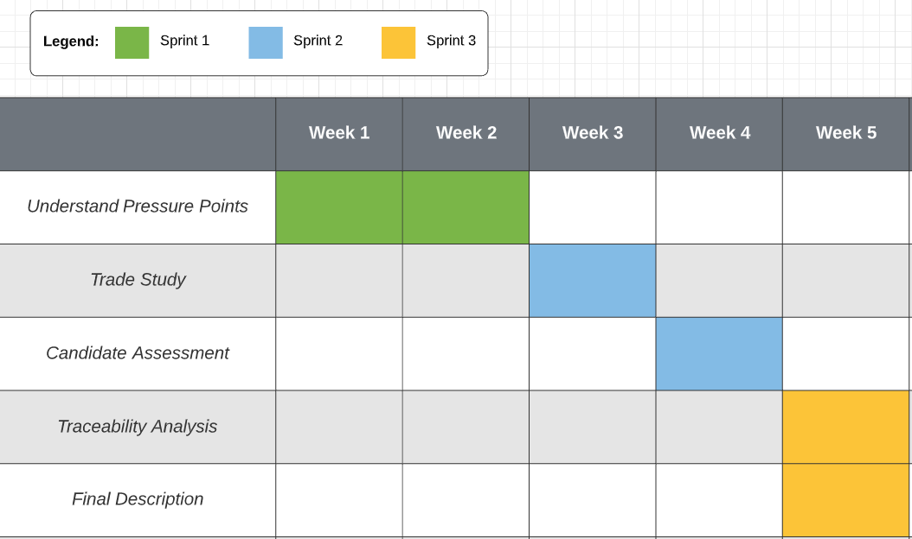

The project management API project demands the team decide not only on the requirements but also how the requirements will be implemented. An algorithm for creating the design is depicted as follows: understand the pressure points; conduct a trade study; assess the selected candidate; affirm design validity; provide design description (see Figure 1). First, by knowing the user mission the true design drivers can be identified. This is critical because the customer may be focusing on a detail not impacting their problem.

A trade study is a process that produces candidate designs and identifies the rank of each candidate. The process enables us to find the right balance of features and choose the right solution. The project’s study needs to effectively measure performance.

Operational performance measures and technical performance measures can measure the fit of each candidate. Both metrics are necessary because increased performance in one area does not always guarantee performance in the other. Moreover, the study is responsible for creating and evaluating candidates for selection.

The design selected will be evaluated across four axes. Design performance and capacity will be analyzed through modeling and benchmarking. API stability will be controlled through input type guards and error handling. To account for flawed implementation, the API must be built with a design margin in mind. Each API component should maintain a single responsibility; this allows engineers to identify errors sooner. This approach is part of circumventing design pitfalls. Engineers should implement the API with the intention of avoiding unwanted dynamic behavior.

The engineers can confirm for themselves and the stakeholders that all requirements have been accomplished through a traceability analysis. Every requirement must be mapped within the API. Lastly, the final design will be further elaborated and explained, and will provide the engineering team direction in generating user stories.

**References**

Siegel, N. G. (2019). *Engineering Project Management.* John Wiley & Sons Ltd.